Send mail with attachment from Pycharm:

1. Open your mail id and keep it ready. Browse through that only.
2. Type the program get the error and paste the error in chrome search.

# Python code to illustrate Sending mail with attachments

# from your Gmail account

import smtplib

from email.mime.multipart import MIMEMultipart

from email.mime.text import MIMEText

from email.mime.base import MIMEBase

from email import encoders

mail_content = '''Hello,

This is a test mail.

In this mail we are sending some attachments.

The mail is sent using Python SMTP library.

Thank You

'''

#The mail addresses and password

sender_address = 'sender123@gmail.com'

sender_pass = 'xxxxxxxx'

receiver_address = 'receiver567@gmail.com'

#Setup the MIME

message = MIMEMultipart()

message['From'] = sender_address

message['To'] = receiver_address

message['Subject'] = 'A test mail sent by Python. It has an attachment.'

#The subject line

#The body and the attachments for the mail

message.attach(MIMEText(mail_content, 'plain'))

attach_file_name = 'TP_python_prev.pdf'

attach_file = open(attach_file_name, 'rb') # Open the file as binary mode

payload = MIMEBase('application', 'octate-stream')

payload.set_payload((attach_file).read())

encoders.encode_base64(payload) #encode the attachment

#add payload header with filename

payload.add_header('Content-Decomposition', 'attachment', filename=attach_file_name)

message.attach(payload)

#Create SMTP session for sending the mail

session = smtplib.SMTP('smtp.gmail.com', 587) #use gmail with port

session.starttls() #enable security

session.login(sender_address, sender_pass) #login with mail_id and password

text = message.as_string()

session.sendmail(sender_address, receiver_address, text)

session.quit()

print('Mail Sent')

1. Error: smtplib.SMTPAuthenticationError: (535, b'5.7.8 Username and Password not accepted.

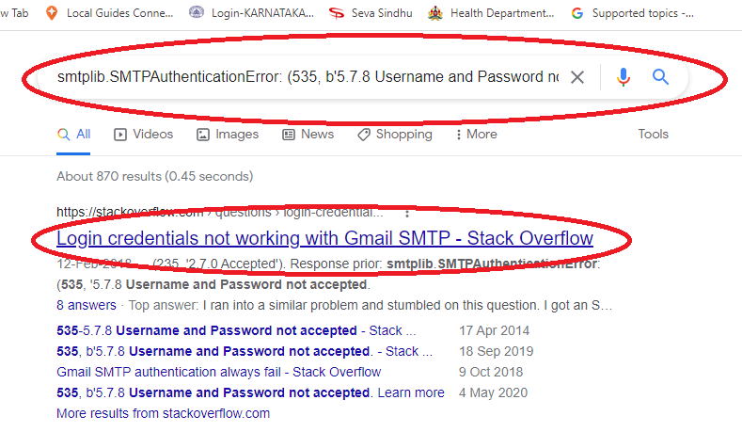

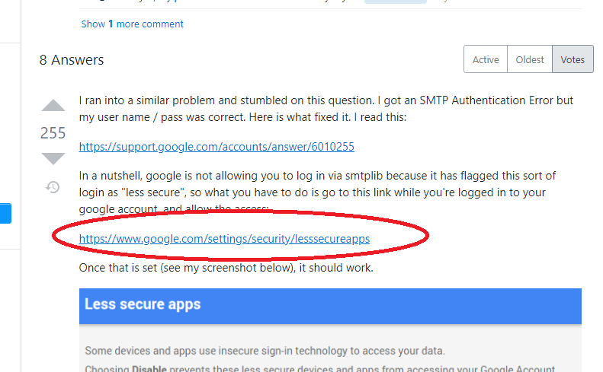

#or <https://www.google.com/settings/security/lesssecureapps>

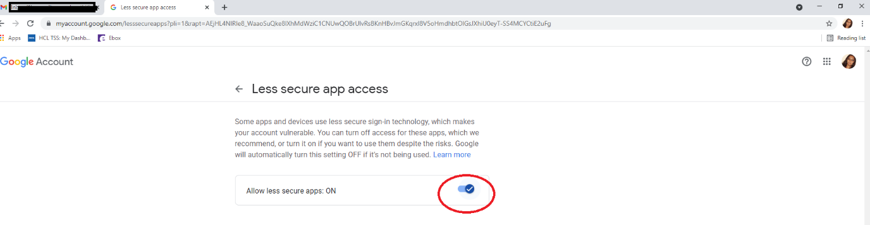

If one more level security is there: click on your profile photo in gmail and then ‘manage your google account’

